[Ebook store]
Process Model

Date | [March 18, 2010]
Version | [1.0]
Status | []
Author | [Le Hoang Dinh Tuan, Developer]
Reviewed by | [Le Hoang Dinh Tuan]
Approved by | []

Revision History

Date | Version | Description | Author

Table of Contents
1 Introduction 4
1.1 Purpose 4
1.2 Scope 4
1.3 Definitions, Acronyms and Abbreviations 4
1.4 References 4
1.5 Overview 4
2 Process View 5
2.1 sCMS 5
2.1.1 Change Key 5
2.1.2 Clear card 6

Introduction

Purpose
This view is OPTIONAL. Use this view only if the system has more than one thread of control, and the separate threads interact or are dependent upon one another]

Scope

Definitions, Acronyms and Abbreviations

No | Term | Description

References

Overview

Process View

sCMS
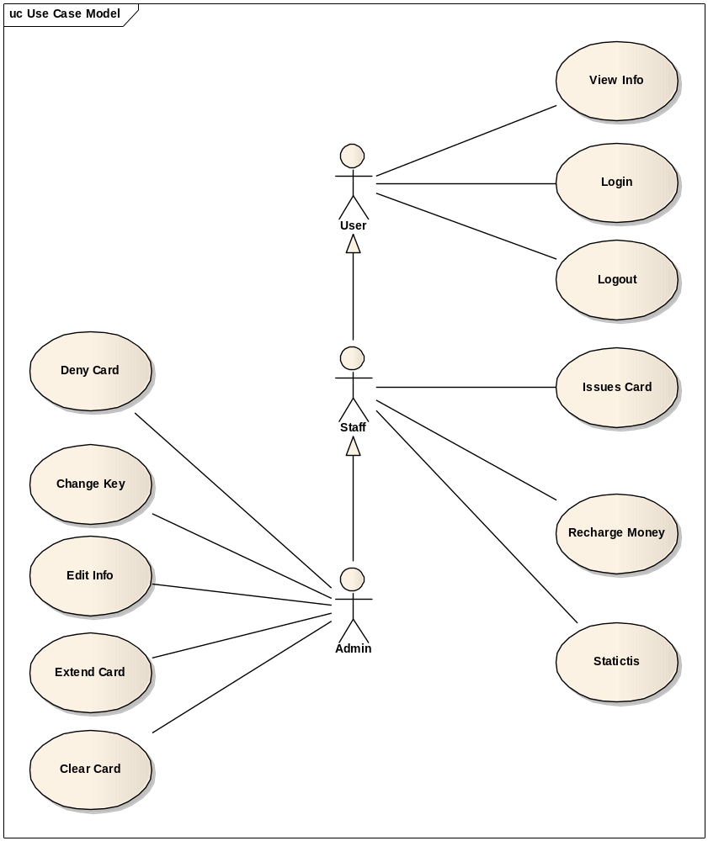

Change Key
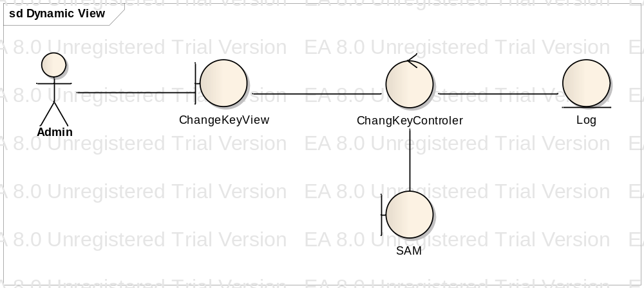

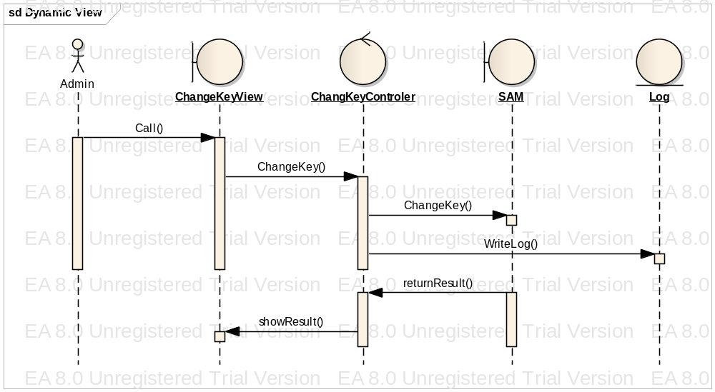

Clear card
